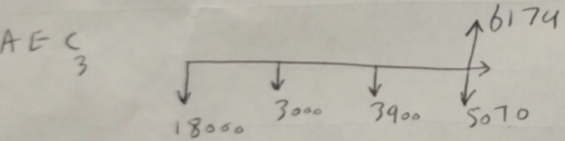Suppose a company has a forklift but is considering purchasing a new electric lift truck that would cost $18,000 and has operating cost of $3,000 in the first year. For the remaining years, operating costs increase each year by 30% over the previous year’s operating costs. It loses 30% of its value every year from the previous year’s salvage value. The lift truck has a maximum life of eight years. The firm’s required rate of return is 4%. Find economic service life of this new machine. Explain your answer.

PW(4%) = 18000 - (18000*(1-.3) -3000)(1+.04)-1 = 8769.23 ; AEC1 = 8769.23(.04*1.04/((1+1.04)-1)) = 9120;

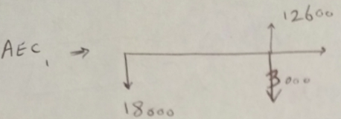

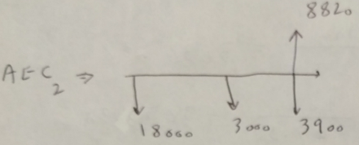

PW(4%) = 18000 + 3000(1.04)-1 - (8820-3900)(1.04)-2 = 16335.8; AEC2 = 16335.8(.04*1.042/(1.042-1)) = 8661.1

PW(4%) = 18000 + 3000(1.04)-1 - (12600*.7-3900)(1.04)-2 = 16335.8;AEC2=16335.8(.04*1.042/(1.042-1)) = 8661.1

… same process for year 4; AEC4 > AEC3, so the econ. serv. life is 3 years.

On 10/2/2014, Jack paid $120,000 for a residential rental property. This purchase price represents $100,000 for the cost of the building and $20,000 for the cost of the land. On 2/13/2017, he sold the property for $130,000. Compute the MACRS depreciation for each year of the four calendar years during which Jack owned the property. **Hint**: Investments in residential rental property are written off in straight-line fashion over 27.5 years.

dep(yr 1) = 2.5/12 * (100000/27.5) = 757.57 ; dep(yr 2) = 100000/27.5 = 3636.36 ; dep(yr 3) = 100000/27.5 = 3636.36 ; dep(yr 4) = 1.5/12 * (100000/27.5) = 454.54 ;

Consider the following project’s after-tax cash flow and the expected annual general inflation rates during the project period.

PW = -17,000 + 44,117.65/1.03 + … + 43,988.65/(1.03)5 = 25,462.23 > 0, so accept

* Convert the cash flows in actual dollars into equivalent constant dollars with the base year 0. *(complete the table for constant dollars cash flow)*
* If the annual inflation-free interest rate is 3%, what is the present worth of the cash flow? Is this project acceptable?

|  |  |
| --- | --- |
| year | Inflation rate |
| 0 |  |
| 1 | 2% |
| 2 | 3% |
| 3 | 3% |
| 4 | 1% |
| 5 | 4% |

The inflation rate for product XYZ in years 2012, 2013, 2014, and 2016 were 3.32%, 4.1% 2.22%, and 1.99%, respectively. If the average annual inflation rate from year 2012 to 2016 was 3.56%, what was the inflation rate in year 2015?

(1 + f)5 = (1 + f1) * (1 + f2) * … * (1 + f5) => (1 + .0356)5 = (1 + .0332) * (1 + .041) * (1 + .0222) * (1 + f4) * (1 + .0199) => 1.1911 = 1.1213 * (1 + f4) => f4 = 6.226%

|  |  |
| --- | --- |
| actual cash flow | |
| year | amount |
| 0 | - $170,000 |
|  | $ 45,000 |
| 2 | $ 45,000 |
| 3 | $ 35,000 |
| 4 | $ 55,000 |
| 5 | $ 50,000 |

|  |  |
| --- | --- |
| Constant dollars cash flow | |
| year | amount |
| 0 | -170,000 |
| 1 | 45,000 * (1 + .02)-1 = 44,117.65 |
| 2 | 45,000 * (1.02)-1 * (1.03)-1 = 42,832.67 |
| 3 | 35,000 * (1.02)-1 * (1.03)-1 * (1.03)-1 = 32,343.98 |
| 4 | 55,000 * (1.02)-1 * (1.03)-2 * (1.01)-1 = 55,323.02 |
| 5 | 50,000 * (1.02)-1 * (1.03)-2 * (1.01)-1 * (1.04)-1 = 43,988.65 |

A piece of manufacturing equipment is to be purchased for $56500. The money will be borrowed with the stipulation that it be repaid with five equal end-of-year payments at 5% compounded annually. This machine is expected to provide annual revenue of $100000 for six years and is to be depreciated by the MACRS five-year recovery period. The annual operating cost is estimated to be $5000. The salvage value at the end of six years is expected to be $4000. Assume a marginal tax rate of 35% and a MARR of 15%.

* Determine the net income at the end of year 1.
* Determine the after-tax cash flow for this asset at the end of year 1

Cash flow at end of year 1: net income + depreciation - principal repayment = 52,568.75 + 11,300 - 13,050.07 = 53,643

Loan Payment: 56500[(.05*1.055)/(1.055-1)] = 13,050.07; Interest: 56,500*.05 = 2,825; Principal Repayment = 13,050.07 - 2,825 = 10,225; Depreciation = ½ * 2/5 * 56,500 = 11,300;

Taxable Income = Revenue - O & M - Dep. - Int. = 100,000 - 5,000 - 11,300 - 2,825 = 80,875

Income Tax = Taxable Income * .35 = 28,306.25

Net Income = Taxable Income - Income Tax = 52,568.75

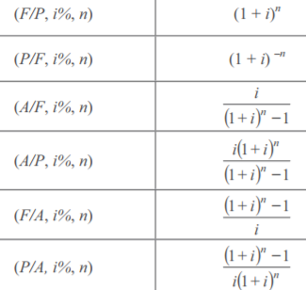

First basic purpose of accounting depreciation: to match the decline in value of an asset with the year in which the decline happens. Principal Payments towards a loan are not viewed as expenses to the borrower, and are therefore not taxed; Consumer Price Index: measure of change over time of prices of goods and services in major expenditure groups (food, housing, apparel); Avg inflation rate f: single avg rate of yearly inflation rates; Gen. infl rate: f` avg infl rate based on CPI for all items; Use half year convention for personal property, mid-month convention for real property; Interest payments are not taxed; Use “generalized cash flow approach” when a project doesn’t change a company’s marginal tax rate; i’ is inflation-free interest rate;

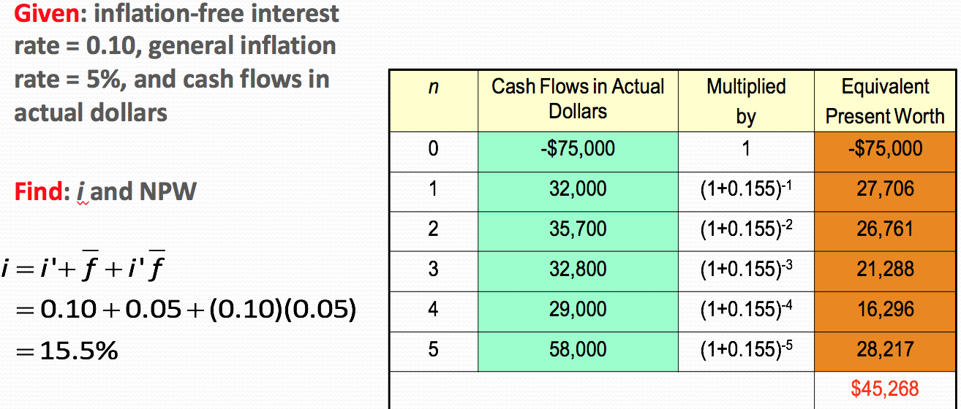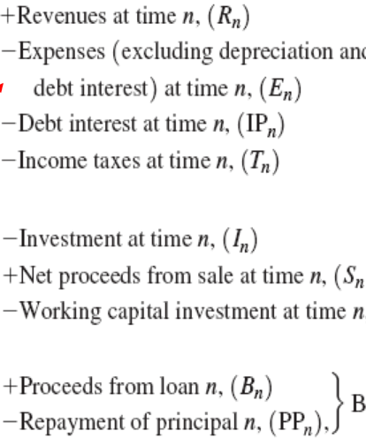

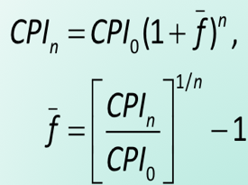

Suppose that a taxpayer places in service a $120000 asset that is assigned to the seven-year class (of depreciation) with a half-year convention. Develop the MACRS deductions (assuming 200% declining-balance rate), followed by switching to straight-line method.

1. DDB: (2/7)(1/2) = 14.29%; $120k * .1429 = $17,142.86; BV = $120k - $17,142.86 = $102,857.14
2. DDB: (2/7)(1-.1429) = 24.49%; .2449 * 120,000 = 29,387.76; BV = 102,857.14-29,387.76 = 73,469.38
   1. SL: (1/6.5)*(1-.1429) = 13.19% < 24.49%, so choose DDB
3. DDB: (2/7)*73,469.38 = 26,991.25 ; BV = 73,469.38 - 26,991.2 = 52,478.13
   1. SL: (1/5.5)* 73,469.38 = 13,358.03 < DDB, so choose DDB
4. DDB: (2/7)* 52,478.13 = 14,993.75; BV = 52, 478.13 - 14,993.75 = 37,484.38
   1. SL: (1/4.5) * 52,478.13 = 11.661.81 < DDB, so choose DDB
5. DDB: (2/7) * 37,484.38 = 10,709.82
   1. SL: (1/3.5) * 37,484.38 = 10,709.82 = DDB, so switch to SL; BV = 37,484.38 - 10,709.82 = 26,774.56
6. … continue w. SL; after last year, BV = $0